[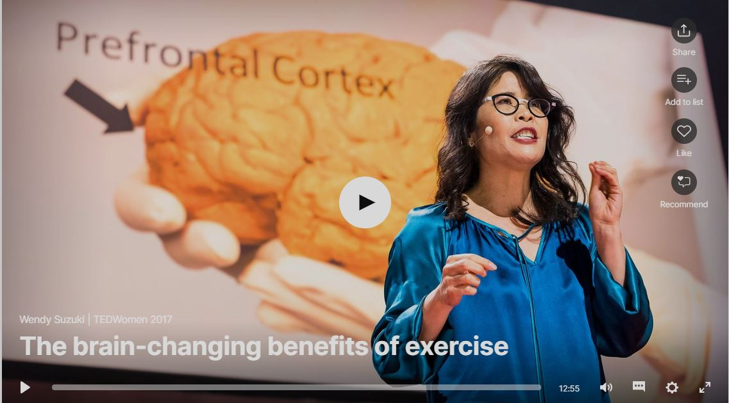](https://www.ted.com/talks/wendy_suzuki_the_brain_changing_benefits_of_exercise?language=en)

The most transformative effect that exercise has is in the protective effects it has on your brain. Here, you can think of your brain as a muscle. The more you are working out, the bigger and stronger your hippocampus and prefrontal cortex becomes. Which is great news, because the prefrontal cortex and the hippocampus are the two areas in the brain that are the most susceptible to neurodegenerative disease and normal cognitive decline in aging. So, with increased exercise over a lifetime, you’re not going to cure dementia or Alzheimer’s disease, but you are going to create the largest and strongest hippocampus and prefrontal cortex so that it takes longer for these diseases to have an effect on your daily life.

The good news from all this research is that these brain-changing effects of exercise can be achieved through a very do-able exercise regime. According to Wendy Suzuki, the rule of thumb is three or four 30-minute exercise sessions per week, being sure to get your heart rate up during those workouts.

Regular exercise produces new brain cells in the hippocampus, which actually increases its’ volume. Additionally, long term exercise produces improved attention function in your prefrontal cortex. And finally, those neurotransmitters that help increase your mood will continue to be produced on an ongoing basis if you continue to exercise regularly.

Exercise is the most transformative thing you can do for your brain for the following three reasons:

1. It has immediate effects on your brain. A single workout will immediately increase levels of neurotransmitters, which is going to boost your mood right after the workout.
2. A single workout can increase your ability to shift and focus your attention and that improvement will last for at least 2 hours following the workout.
3. A single workout will improve your reaction times, which can help you to prevent accidents and injury.

These immediate effects can translate to long-term benefits by simply continuing to exercise on a regular schedule. The effects are long-lasting because exercise actually changes the brain’s anatomy physiology and function.

Dr. Wendy A. Suzuki is a Professor of Neural Science and Psychology in the Center for Neural Science at New York University. Suzuki's major research interest continues to be brain plasticity. She is best known for her extensive work studying areas in the brain critical for our ability to form and retain new long-term memories. More recently, her work has focused on understanding how aerobic exercise can be used to improve learning, memory and higher cognitive abilities in humans.

**The Brain-Changing Effects of Exercise**